AI Agents Architecture

System Overview
Your AI Agent system is a database-driven, multi-provider orchestration platform with specialized agents that can work independently or collaborate through the multi-agent coordinator.

🏗️ High-Level Architecture
AI ProvidersEdge Function (Deno)Database (Supabase)Frontend (React)HTTP RequestQueryAPI CallAPI CallAPI CallProxyUser InterfaceAI Chat ComponentuseAIChat / useChatEngineai_agentsai_agent_capabilitiesai_agent_settingsai-orchestratoragentLoader.ts5-min CacheOpenAI GPT-4ClaudeGeminiLovable AI Gateway 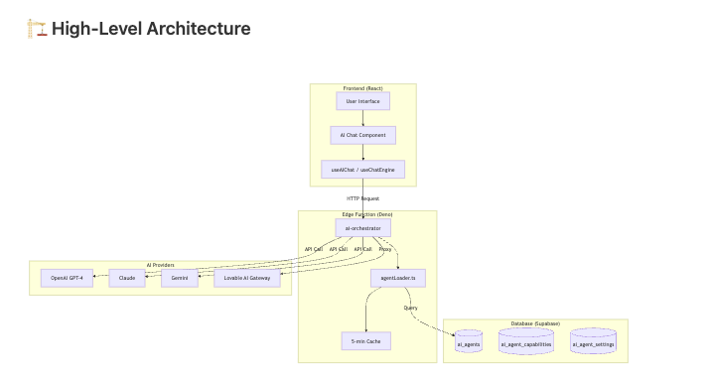

🤖 Agent Types & Specializations
You have 11 specialized AI agents, each with specific capabilities:
Agent Type | Primary Function | Model Provider | Interactions
scheduler | Task scheduling & planning | Configurable | Independent
finance | Budget & cost analysis | Configurable | Independent
risk | Risk assessment | Configurable | Independent
assignment | Resource allocation | Configurable | Independent
meeting | Meeting summaries | Configurable | Independent
document | Document generation | Configurable | Independent
insight | Data analysis | Configurable | Independent
strategic | Strategic planning | Configurable | Independent
communication | Email/messaging | Configurable | Independent
system | System operations | Configurable | Independent
multi-agent | Orchestrates other agents | Configurable | Coordinates all

🔄 Invocation Flow

Single Agent Invocation
AI ProviderDatabaseai-orchestratorHookUIUserAI ProviderDatabaseai-orchestratorHookUIUser{ agentType: 'finance', message: 'What's our burn rate?' }Click "Ask Finance Agent"sendMessage(agentType: 'finance')POST /ai-orchestratorLoad agent config{ model: 'gpt-4', prompt: '...', settings: {...} }API Call with configResponseFormatted responseDisplay responseShow answer

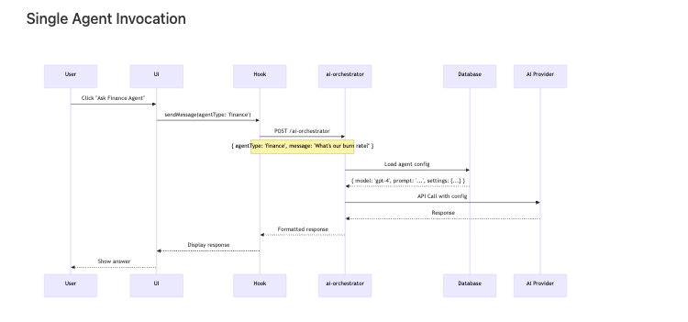

Multi-Agent Orchestration
Databasestrategic agentrisk agentfinance agentmulti-agentUIUserDatabasestrategic agentrisk agentfinance agentmulti-agentUIUserAnalyzes requestDetermines needed agentsSynthesizes responses"Create Q1 budget with risk analysis"Complex requestLoad finance agent"Calculate Q1 budget"Budget projectionLoad risk agent"Analyze budget risks"Risk assessmentLoad strategic agent"Strategic recommendations"Strategic planUnified responseComplete analysis

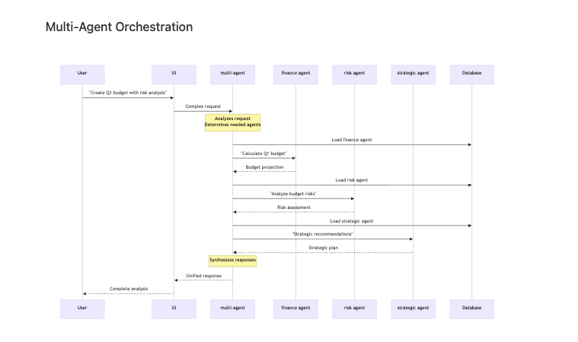

📊 Database Structure

ai_agents Table
┌─────────────┬──────────────┬──────────────┬──────────┐
│ id │ type │ label │ status │
├─────────────┼──────────────┼──────────────┼──────────┤
│ uuid │ scheduler │ Scheduler │ active │
│ uuid │ finance │ Finance │ active │
│ uuid │ multi-agent │ Multi-Agent │ active │
└─────────────┴──────────────┴──────────────┴──────────┘

ai_agent_settings Table
┌─────────────┬──────────────┬─────────────┬─────────────┐
│ agent_id │ model_name │ provider │ max_tokens │
├─────────────┼──────────────┼─────────────┼─────────────┤
│ finance-id │ gpt-4 │ openai │ 2000 │
│ risk-id │ claude-3 │ anthropic │ 4000 │
└─────────────┴──────────────┴─────────────┴─────────────┘

🎯 Key Architectural Decisions

1. Separate Agents, Not One Master Agent
- ✅ 11 independent specialist agents
- Each has its own system prompt, model configuration
- Invoked individually based on context/user selection

2. Multi-Agent Orchestrator
- The multi-agent type is special - it can invoke other agents
- Acts as a coordinator for complex requests
- Example: "Create budget" → calls finance + risk + strategic agents
- Synthesizes their responses into one coherent answer

3. Database-Driven Configuration
- All agent configs stored in PostgreSQL
- Cached for 5 minutes in Edge Function
- Admin UI allows changing models without code deployment

4. Provider Flexibility
- Each agent can use different providers:
  - OpenAI (GPT-4, GPT-3.5)
  - Anthropic (Claude)
  - Google (Gemini)
  - Lovable AI Gateway

🔄 Agent Interaction Patterns

Pattern 1: Independent (Most Common)
User → UI → finance agent → OpenAI → Response
90% of requests - Single agent handles the entire request

Pattern 2: Multi-Agent Orchestration
User → UI → multi-agent coordinator
├→ finance agent → Response 1
├→ risk agent → Response 2
└→ strategic agent → Response 3
→ Synthesized Response
10% of requests - Complex queries requiring multiple perspectives

Pattern 3: Sequential Chaining (Possible but not currently implemented)
User → scheduler agent → (creates tasks)
→ assignment agent → (assigns resources)
→ communication agent → (sends notifications)
Future enhancement - Agent-to-agent handoffs

💡 How It Works in Your UI

Single Agent Chat
typescript
// User clicks on "Finance Agent" chat
<AIChat agentType="finance" />
// Behind the scenes:
const response = await supabase.functions.invoke('ai-orchestrator', {
body: {
agentType: 'finance',
message: 'What is our Q1 budget?',
projectId: currentProject.id
}
});

Multi-Agent Request
typescript
// User asks complex question in general chat
<AIChat agentType="multi-agent" />
// multi-agent determines which specialists to consult
// calls them sequentially, then synthesizes

🎨 Visual Agent Hierarchy
Orchestration LayerSpecialist Agents (Independent)Simple requestSimple requestSimple requestComplex requestDelegates toDelegates toDelegates toSynthesizes👤 User📅 Scheduler💰 Finance⚠️ Risk👥 Assignment📹 Meeting📄 Document💡 Insight🎯 Strategic💬 Communication⚙️ System🤖 Multi-Agent Coordinator

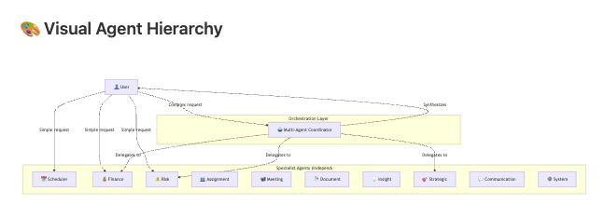

🔍 Agent Discovery & Selection

Auto-Selection (AI Chat)
The UI can automatically select the appropriate agent based on keywords:
- "budget" → finance agent
- "risk" → risk agent
- "schedule" → scheduler agent

Manual Selection
Users can also explicitly choose an agent from the UI:
tsx
<AgentIndicator agentType="finance" />

Multi-Agent Auto-Detection
Complex requests automatically invoke multi-agent:
- Multiple domains mentioned
- Requires synthesis from different perspectives
- Example: "Create Q1 plan with budget and risk analysis"

📈 Scalability & Performance

Caching Strategy
- Agent configs cached for 5 minutes
- Reduces database queries by ~95%
- Cache key: ai-agent-cache-${agentType}

Load Balancing
- Each agent can have different rate limits
- Configured per provider in settings
- Automatic fallback if provider unavailable

✅ Summary
Your Architecture:
- ✅ 11 specialized independent agents
- ✅ 1 multi-agent orchestrator (can invoke others)
- ✅ Database-driven configs (dynamic, no redeployment)
- ✅ Multi-provider support (OpenAI, Anthropic, Google)
- ✅ Separate UI entry points for each agent
- ✅ Cached for performance (5-min TTL)
Agent Interaction:
- Default: Agents work independently (90% of cases)
- Advanced: Multi-agent coordinates specialists (10% of cases)
- Future: Agent-to-agent chaining (not yet implemented)
Key Benefit: Your system is modular and flexible - you can add new agents, change models, or implement agent-to-agent workflows without touching the core architecture.

